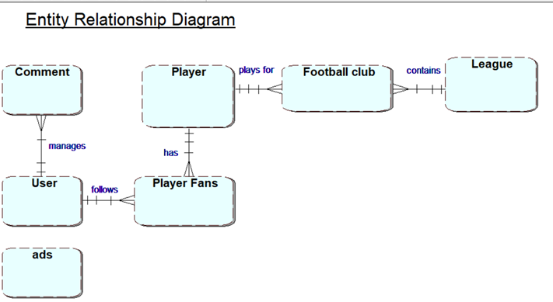

Table types
User (UserID, email, password, role)
Player (playerID, FirstName, LastName, DOB, position, goals, assists, yellow cards, red cards)
PlayerFans (playerID, userID)
FootballClub (footballclubID, clubname, club goals, passes, cleansheets, leagueID)
League (leagueID, league name, description, seasons)
Advert (advertID, image, description, leagueID)
Comments (commentID, rating, date, playerID, userID)

